**Network Monitoring Using Zabbix**

**Lab setup and explanation by Bhargav Gosai**

**Zabbix Installation**

**Lab Workbook**

Part 1: Install Ubuntu Server (If you have a previous Ubuntu server running, use that)

Part 2: Install Zabbix

Part 3: Install Windows server 2019

Part 4: Install Heavy loader on Windows server

Part 5: Enable Zabbix monitoring on Windows server 2019

Part 6: Execute Load runner on windows to generate load

**Lab Objectives**

Upon completion of this lab, you will be able to perform the following:

* Zabbix Installation
* Install Windows 2019 Virtual Machine (VM).
* Monitor the Windows server 2019 server using Zabbix
* Run Heavy loader application on Windows server 2019

**Lab Materials**

* Install Ubuntu server
* Install Zabbix Server
* Install Windows Server 2019 VM
* Use Zabbix to monitor the Windows Server 2019

**Lab Requirements**

* VMware workstation 16 pro Or Virtualbox
* Ubuntu server
* VMware workstation 16 pro
* Windows server 2019
* Heavy loader application

**Part 1: Ubuntu server Installation (Command line)**

1. Download Ubuntu Server 20.04 from here: <https://ubuntu.com/download/server> (choose “**manual server installation**” to get the download file)
2. Create a new Virtual Machine (VM) using the Ubuntu Server 20.04 iso from the link above
   1. For the username setup, use your first name and last name initials e.g., bhargavg
3. Once the server is installed, login with your created username just as seen below.

**Install SSH on the Ubuntu server using the following instructions (Ignore this if your Ubuntu server has SSH installed).**

1. Use the command *ip a* to confirm your server’s IP address or run the command   
   sudo apt install net-tools to be able to use ifconfig command.
   1. Make sure that you can ping the IP from your local Windows computer
2. On your local Windows computer (NOT your ubuntu machine) create an ssh keypair: open command prompt and type: ssh-keygen
3. Once the keypair is created, copy the public key to a safe directory with the command:copy C:\Users\yourUserName\.ssh\id_rsa.pub C:\Users\yourUserName\authorized_keys
4. Go back to your Ubuntu server
5. Start the SSH service using the commands:

sudo apt install openssh-server

sudo ufw allow ssh

1. switch to the ssh directory with the command: cd /home/[YourUsername]/.ssh
2. Go back to your Windows host computer
3. Open command prompt and use the command: *cd C:\Users\yourUserName*
4. Copy your public ssh key to the ubuntu server using the command:
5. scp authorized_keys username@UbutnuServerIP:~/.ssh
6. Go back to your Ubuntu server
7. Adjust the permission settings for the ssh share and public ssh key file:

chmod 700 ~/.ssh

chmod 600 ~/.ssh/authorized_keys

1. Go back to your Windows host computer
2. Log into your Ubuntu machine from the Windows command prompt with the command:   
   ssh username@UbuntuServerIP
   1. You should not be prompted for a password
      1. **Example:**

**Part 2: Installation of the Zabbix server**

1. It is recommended to update your VM before installation to ensure all dependencies are updated. Then install the mysql server.

Run the system update of all the packages using the command below

$ sudo apt update

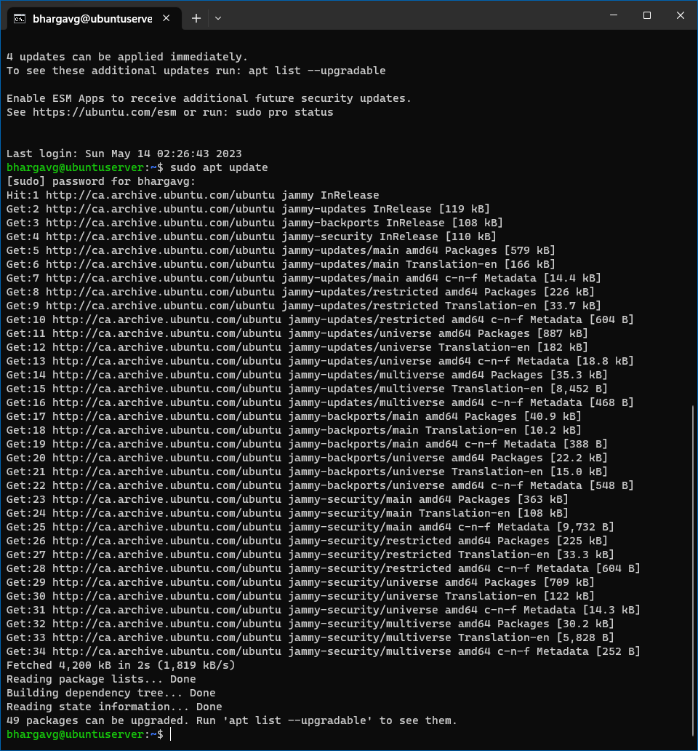

1. Then install the mysql-server package using the following command:

$ sudo apt install mysql-server

1. Ensure that the server is running using the systemctl start command:

$ sudo systemctl start mysql.service

1. **Go to the link to see the commands for installing Zabbix**

[**https://www.zabbix.com/download?zabbix=6.4&os_distribution=oracle_linux&os_version=9&components=server_frontend_agent&db=mysql&ws=apache**](https://www.zabbix.com/download?zabbix=6.4&os_distribution=oracle_linux&os_version=9&components=server_frontend_agent&db=mysql&ws=apache)

**Select the following combinations as seen in the screenshot below.**

1. **Scroll down the page to see the installation instructions. This shows all the steps needed to be taken to install our Zabbix server. See screenshot below**

1. SSH into the Ubuntu server to make it easier to copy and paste your commands. Using the command  
   > ssh username@UbuntuServerIP  
   > ssh [bhargavg@192.168.29.137](mailto:bhargavg@192.168.29.137)
2. **p-**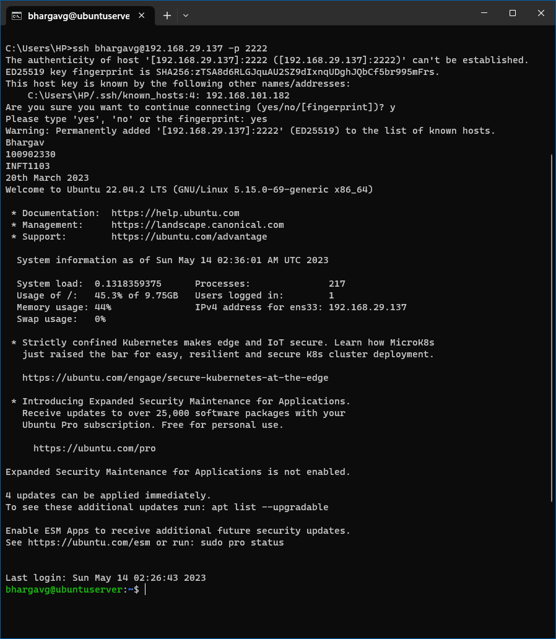

Proceed with installing the zabbix repository using the command in the section above.# wget https://repo.zabbix.com/zabbix/6.4/ubuntu/pool/main/z/zabbix-release/zabbix-release_6.4-1+ubuntu20.04_all.deb  
# sudo dpkg -i zabbix-release_6.4-1+ubuntu20.04_all.deb  
# sudo apt update

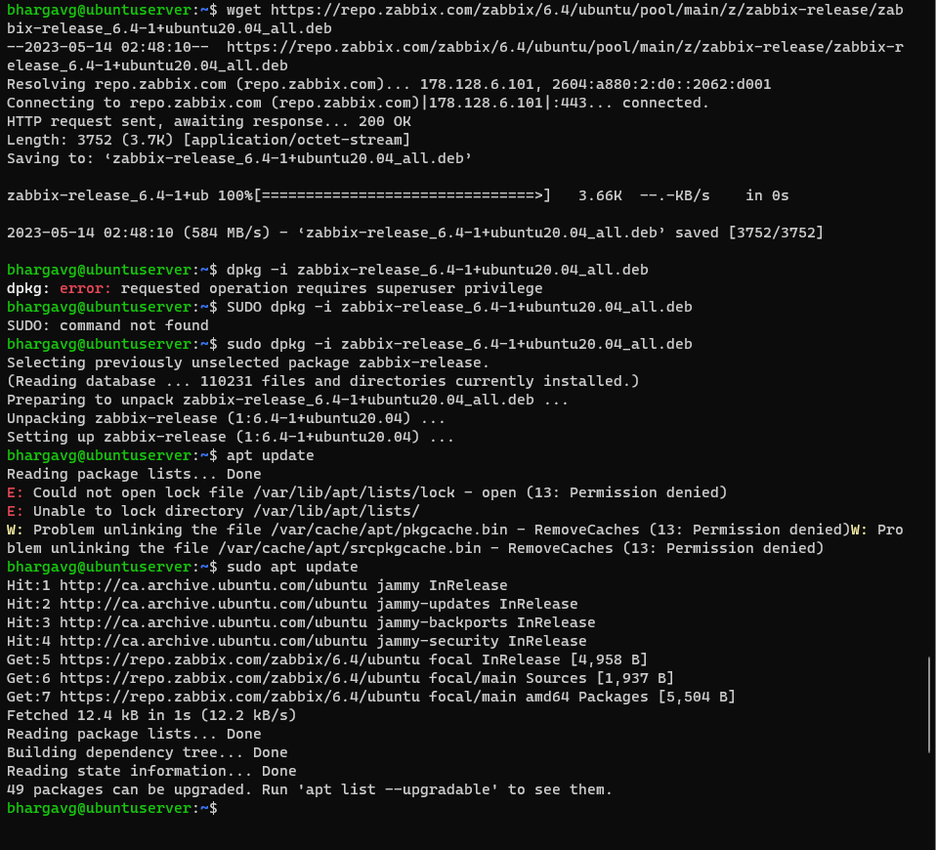

1. Run the system update once again using the below command.  
   $ sudo apt update

1. Next step would be to Install Zabbix server, frontend, agent to the Ubuntu server you installed.

$ sudo apt install zabbix-server-mysql zabbix-frontend-php zabbix-apache-conf zabbix-sql-scripts zabbix-agent -y

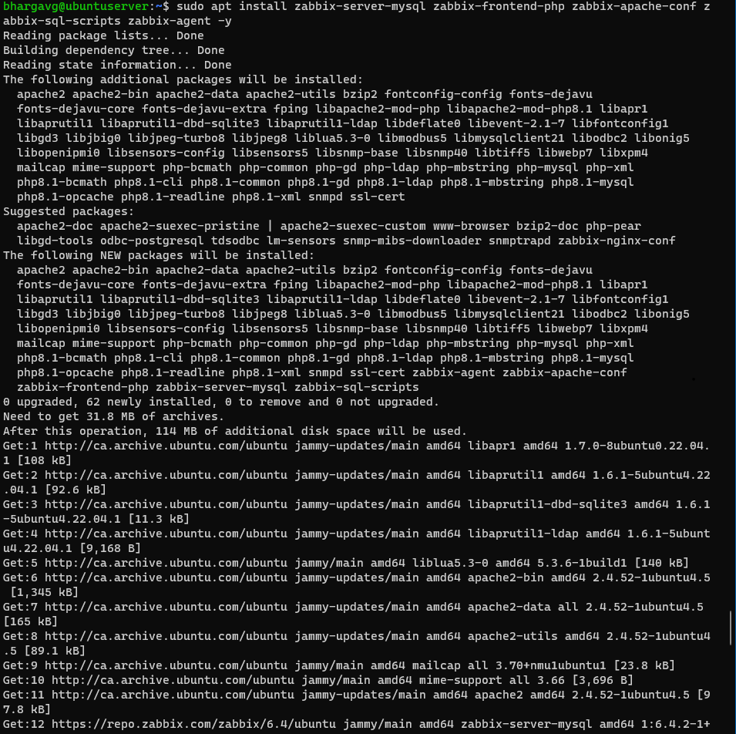

**Zabbix Database Installation**

1. Good work, next step would be to create the initial zabbix database on the ubuntu server VM.

Make sure you have database server up and running from step 3 above.

First switch to the root user using sudo su.

$ sudo su

1. Then use the command mysql (we don’t need to add -p because we do not have a password configured)# mysql

1. Next step would be to create our database using the command> create database zabbix character set utf8mb4 collate utf8mb4_bin;



1. Next would be to create our zabbix user using the command below.  
   > create user zabbix@localhost identified by 'zabbix';

1. Next step would be grant our zabbix user the privileges to access the database using the command below.

> grant all privileges on zabbix.* to zabbix@localhost;

1. Next, set the trust functions using the following command below**.**

> set global log_bin_trust_function_creators = 1;

1. On Zabbix server host import initial schema and data. You will be prompted to enter your newly created password from step 4 above. In my own case, I used zabbix as my password.

First change your directory using the command

# cd /usr/share/zabbix-sql-scripts/mysql/

Then run the command import initial schema and data

# zcat server.sql.gz | mysql Zabbix

1. Next step would be to configure the database for the Zabbix server

Open the Zabbix server configuration file to confirm the dbuser and password. Use the below command

# nano /etc/zabbix/zabbix_server.conf

Confirming the name used for the mysql database

**Before update**

**After update**

1. Save the configuration file using ctrl o on your keyboard and use ctrl x to exit, then start the Zabbix server and agent processes and check the status using the command below. The status should show active (running).

Command to restart the Zabbix server, Zabbix agent and apache2

# systemctl restart zabbix-server zabbix-agent apache2

Command to enable the Zabbix server, Zabbix agent and the apache2

# systemctl enable zabbix-server zabbix-agent apache2

Command to check the status of your zabbix server, zabbix agent and apache2. Note use the down button on your keyboard to see the other agents running

# systemctl status zabbix-server zabbix-agent apache2

Zabbix server running

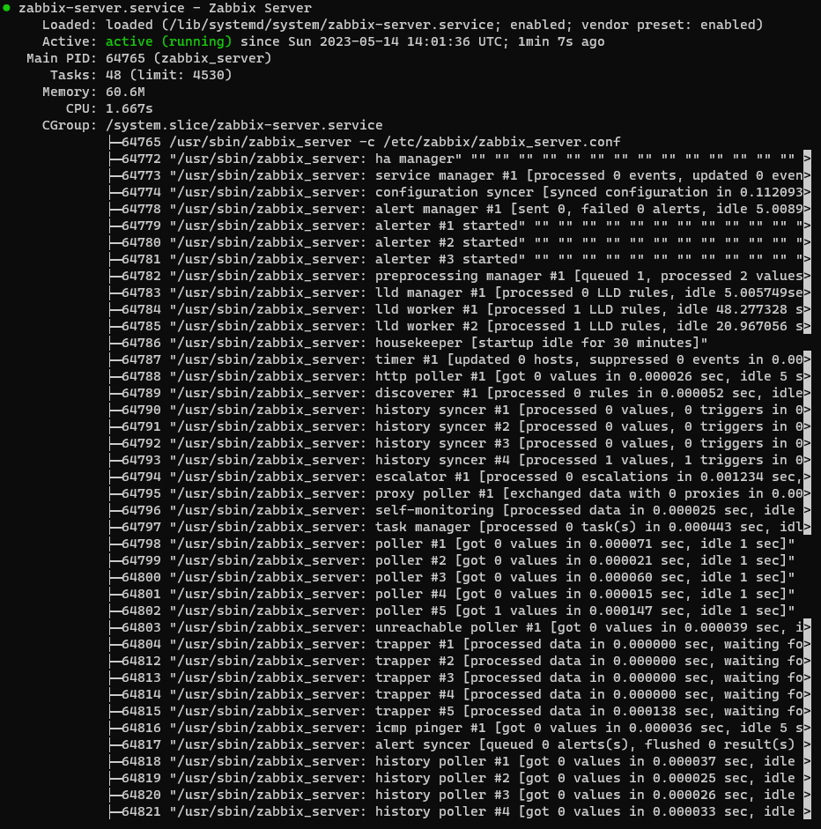

**Zabbix agent running**

**Apache2 service running**

Access to the Zabbix web interface

1. Now go to your browser on your host machine to access the Zabbix setup using the IP address of your Virtual machine. (Note: On your host machine e.g. windows operating system)

Go to your zabbix VM to run the ip a command to check what your zabbix server IP address is. Mine is 192.168.80.206. Yours would be different.

[**http://yourZabbixIP/zabbix**](http://yourZabbixIP/zabbix)

[**http://192.168.29.137/zabbix**](http://192.168.29.137/zabbix)(Note, your IP address would be different from mine and ensure you add the /zabbix to it)

1. Once the setup page comes up, you can leave the default language as English and click on next.

1. **All pre-requisites should be showing OK, then click next.**

1. Ensure every box is checked correctly and add the zabbix user and password created from the initial installation. Click next if everything is complete

1. Make your Zabbix server name your name with this naming convention “Zabbix-Yourname” for the Zabbix server name. In my case I used Zabbix-Bhargav. Then click next

1. Check the pre-installation summary to make sure there are no errors.

1. Then you should see the congratulations! message of a complete installation of Zabbix. Click finish

1. You will notice your server’s name has changed to the name you added. Pretty cool right!! Input the default zabbix username and password to login.   
   Username: Admin  
   Password: zabbix

**Congratulations, you have Zabbix installed**

**Part 2 – Zabbix SNMP Agent Installation**

**Part 1: Windows 2019 Server Installation**

1. Go to your Azure cloud portal “https://portal.azure.com/” to download windows server 2019
2. Download windows server 2019/2022.

1. Install the windows 2019 server on your VMware Workstation

1. After the installation, Go to VM > Settings of the new installed Windows server virtual machine to change the memory and processor settings.  
   - Memory: 4 GB  
   - Processors: 1

**Part 2: Heavy loader application installation on Windows server**

Turn on your newly installed Windows server to install the heavy loader application.

1. Go to the website <https://www.jam-software.com/heavyload?ca=1> to download the heavy loader application setup.
2. This can be downloaded on your desktop or download folder. After downloading, double click on the setup to install.
3. Click yes to allow the application to run and follow the prompt
4. You can choose to create a desktop shortcut after installation.
5. Uncheck the Launch heavy Load now and click finish  
     
   A screenshot of a computer program

   AI-generated content may be incorrect.

**Part 3: Enable Zabbix monitoring on Windows 2019 server**

Go to the windows server 2019 and install SNMP using the server manager

1. Install SNMP Service in Windows Server 2019.

• Open Server Manager

• Click Add roles and features

• Under Before you begin click Next

• Under Select installation type click Next

• Under Select destination server click Next

• Under Select server roles click Next

• Under Select features select SNMP Service and click Add Features and then click Next

1. Select SNMP Service

• Under Confirm installation selection click, Install

• Wait until the installation is finished

1. Once the installation is done, Open the Services applet (click on the Start menu and search for services) and click Apply and OK to start the ‘SNMP Service’
2. Click the ‘Agent’ tab and specify the following details:

* Contact: ZabbixMonitor
* Location: Windows-SERVER
* Here, select the following services:
  + Physical, Applications, Internet, End-to-end, then click ‘OK’.

1. Click the ‘Security’ tab on the same dialog box and click Add, to add the community.
2. Input the community name is ‘ZabbixMonitor’ here and the Community rights: ‘READ ONLY’ then click ‘Add’.
3. Select ‘Accept SNMP packets from any host’

1. The next step would be to add your Windows server Machine as a host in your Zabbix instance.

Go to the ‘Data Collection’ tab in your Zabbix, then click ‘Hosts’.

1. Click ‘Create host’.
2. Use the host name: Windows_SERVER_Yourname, in my own case, I used Windows_SERVER_Bhargav.

1. Then click on select by the templates section
2. Click ‘Select’ to add the Template group as ‘Templates/Operating Systems’.
3. Choose ‘Windows SNMP’ and click ‘Select’
4. Now click the ‘Select’ in *Host groups.
5. In Host groups, choose everything and click ‘Select’.
6. In Interfaces, click ‘Add’ to configure the SNMP Interface.
7. Select SNMP from the drop down.
8. Configure the following values for SNMP Interface:

• IP address: (Your Windows Server 2019 IP Address) mine was 192.168.108.132

• Port: 161

• SNMP version: SNMPv2

• SNMP community: {$SNMP_COMMUNITY}

**Before Editing**

**After Editing**

Go to ‘Macros’ tab then enter the following details:

• Macro: {$SNMP_COMMUNITY}

• Value: ZabbixMonitor

Then click ‘Add’.

1. Confirm that the status of your newly added agent is enabled.



**Part 4: Execute the load runner on Windows to generate load**

1. Launch the LoadRunner application from your windows server machine to generate a high CP usage.
2. This would simulate generating load on the Windows Machine and check the status in Zabbix.
3. Else manually run some applications on Windows-SERVER to generate load.

1. Go over to your Zabbix instance through your browser and click on Dashboard, you should see a current problems tab. Showing a high memory utilization has been reported on your Zabbix server.

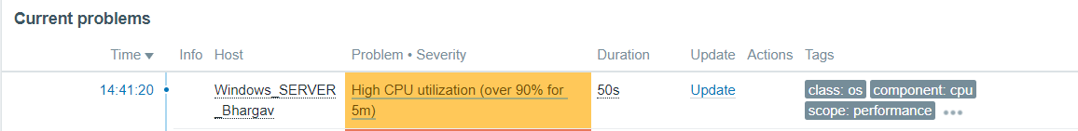

1. Click on the **Monitoring > hosts** in the left menu tab section to see the problems row. Click on the problems to see the details of the problem reported.
2. Check to see the Status of the problem



1. Click on the problem section to click the History > Physical Memory: Memory Utilization.
2. This would display a graph of the high CPU utilization usage of your windows server 2019.

1. Go over to your windows 2019 server to stop the heavy loader application
2. Once you have stopped the heavy loader software, go back to your Zabbix instance to see the status of your problems. You should see a RESOLVED status and PROBLEM status.



1. Click on the hosts from the left menu tab. Navigate to the graph row, to open the graphs.
2. The page containing all the graphs from your windows 2019 server should be displayed

Congratulations, you have completed the Zabbix monitoring configuration on your Windows Server 2019.